MEDICAL UNIVERSITY – PLEVEN

FACULTY OF MEDICINE

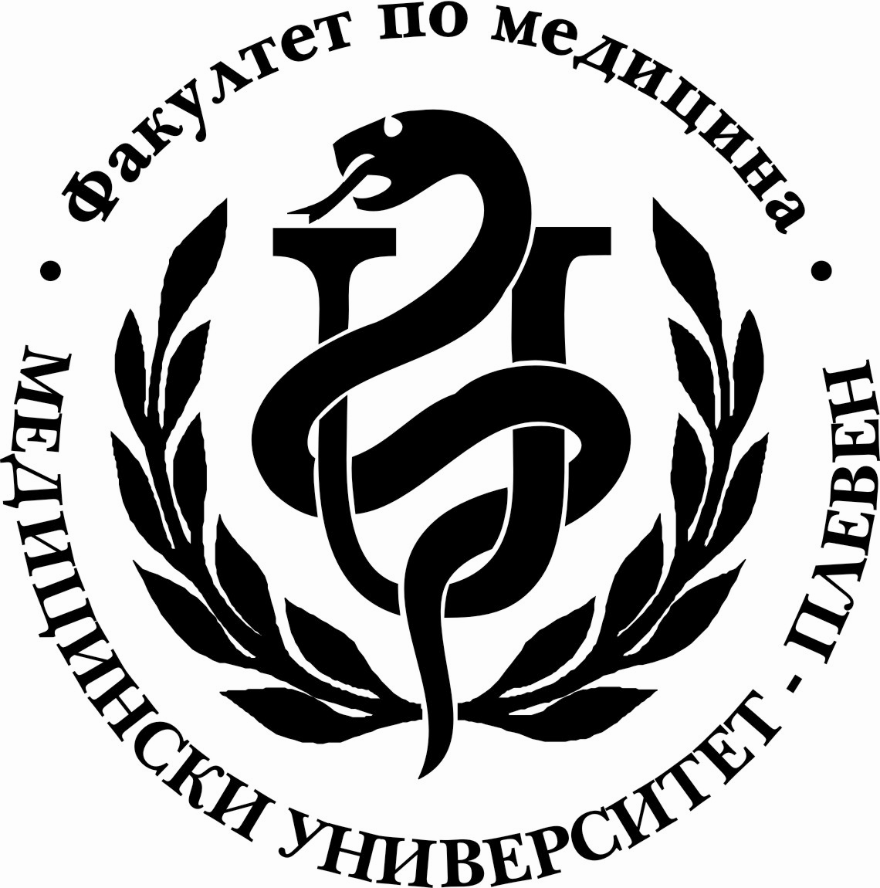

D I A R Y

COMPULSORY SUMMER PRACTICE

OF …………….……………….........……………… STUDENT OF IVTH COURSE, FAC.№ …...…
MEDICAL UNIVERSITY – PLEVEN

FACULTY OF MEDICINE

D I A R Y

of compulsory summer practice

of …………….………………….........……………… a fourth year student,

fac. № ELE…..…, group №……….

Hospital ….………….……...... in…....................…….……….....

from…...…....…. to ….…....…. (totally 30 days)

Date | Working days | Activities | Signature of chief nurse
 | 1
 | 2
 | 3
 | 4
 | 5
 | 6
 | 7
 | 8
 | 9
 | 10
 | 11
 | 12
 | 13
 | 14
 | 15
 | 16
 | 17
 | 18
 | 19
 | 20
 | 21
 | 22
 | 23
 | 24
 | 25
 | 26
 | 27
 | 28
 | 29
 | 30

Student’s grade is: Very good; Satisfactory; Not satisfactory /underline the correct grade/

Head of medical centre:……………………………………………….
/signature/seal//

M E D I C A L U N I V E R S I T Y – P L E V E N

F A C U L T Y O F M E D I C I N E

PROGRAMME
OF COMPULSORY SUMMER PRACTICE ACTIVITIES OF STUDENTS IN MEDICINE AFTER
COMPLETED 8TH SEMESTER

TYPE OF ACTIVITIES

І. IN OBSTETRICS AND GYNECOLOGY CLINIC – DURATION OF PRACTICE ONE WEEK
- Admittance of a pregnant for delivery
- Admittance of a patient with gynecology disease
- Preparation for operational delivery
- Apparatus methods in the Obstetrics and Gynecology
ІІ. IN ENDOCRINOLOGY CLINIC – DURATION OF PRACTICE ONE WEEK
- Admittance /history taking, an objective status/ of a patient with type I diabetes and preparation of a treatment scheme with insulin or oral medicines
- Behavior in cases of severe complications of diabetes - hypoglycemia, diabetic ketoacidosis, hypersmolar non-ketonic coma, lactic acidosis
- Behavior in cases of chronic complications - retinopathy, nephropathy, polynephropathy
- Admittance of a patient with a thyroid disease - thyrotoxicosis, hypothyrodism, acute and chronic thyroditis
- Examination of clinical cases – patients with rare endocrinology diseases of the hypothalamus, the hypophysis/tumors of the hypophysis – prolactinomas, acromegaly, insipidus diabetes/ and the adrenal system /hypocorticism, hyperglucocortisism/
- Clinical collegiums with presentation of cases prepared by students
ІІІ. IN NEUROLOGY CLINIC – DURATION OF PRACTICE ONE WEEK
- Participation in determining of neurological status
- Participation in performing of lumbar puncture
- Participation in making an EMG test
- Participation in making an EEG test
- Reanimation cares for a patient with a neurological disease
- Accompanying patients with a neurological disease for ЕMG and ЕEG
- Become acquainted with the rehabilitation of patients with a neurological disease
- Participation in the fulfillment and reading the results of differential diagnosis.
- Participation in clinical-analytical meetings and section of brains

ІV. IN PULMOILOGY CLINIC –DURATION ONE WEEK
- Become acquainted with the organization of the Pneumology and Phthisiatry Clinic. Kind of departments and sectors
- Become acquainted with the ‘Case chart’ of patients treated in the respective departments of the clinic
- Водене на болничната документация – отразяване развитието на заболяването /декурзуси/.
- Take part in visitation and chief visitation in non-specific department
- Take part in visitationстие and chief visitation in Intensive care department
- Take part in morning report and in handing over a duty
- Demonstration of interesting clinical cases
- Take part in diagnostic treatment of a patient with lung disease – taking and treatment of materials for a microbiological test – sputum, haemoculture
- Become acquainted with invasive bronchoscopic procedures
- Observation of patients with applied invasive and bronchoscopic procedures
- Roentgenological diagnostics – examination and interpretation of roentgenological documentation of interesting cases
- Participation in performance of a lung-function test
- Take part in admission and treatment of a newly admitted patient
- Take part in admission and treatment of a seriously ill patient admitted at the Intensive care department.
- Nursing of a seriously ill patient in Intensive care department
- Treatment and nursing of a patient with chronic respiratory insufficiency
- Preparation of patients for and assisting in pleural puncture
- Intramuscular and intravenous injections and operating with equipment for venous infusions and blood transfusions; operating with a perfuser
- Take part in instruction of patient with obstructive diseases in inhalation technique
- Take part in rehabilitation of a patient with a lung disease
- Take part in discharging of a patient with a lung disease

